NITNC MEETING MINUTES October 8, 2024 40 Attendees

Terry Deno opened the meeting at 6:30 p.m.
Jeanine McKinney gave the Treasurer’s Report.
$81.00 was donated from the September meeting. $475.26 was used to purchase a picnic table for the library garden. The table was delivered on 9-27-2024 but not yet installed. The balance at 9/30/2024 is $6277.59.

Captain Tom Hendron said the number of crimes reported in our neighborhood remains low. There have been some groups at night out looking for unsecured cars and garages. The new Chief of Police is Kevin Hall. Twenty officers have retired recently.

Zack Zappone gave an update for the City Council.
The Spokane City Council has been working on the budget and recently voted on an ordinance regarding the Community Safety Sales Tax. It will be on the ballot in November. They are requesting a one tenth % increase in sales tax. The proposed increase would be used to replace some outdated Fire fleet, update equipment, and relaunch the Neighborhood Resource Program.

It was time to hold the election for our NITNC Neighborhood Council Officers. Since there were no nominations or requests to change the existing officers, a vote was taken and passed unanimously to retain the current officers for another year.

Judge Tim Fennessy is seeking re-election for position 11 as Superior Court Judge. He spoke about his qualifications and experience on the bench for 8 years.

Nick Hamad presented an update on the Meadowglen Park plans and progress. The Park will cover about 14 acers. The high priorities include a playground, restrooms, parking areas and walking trails. Secondary priorities include sport courts, picnic areas and dog areas. Funding will be provided by a combination of grants and city funds. Construction is planned to begin in Spring of 2026 with a target opening in Fall of2026.
Michelle McCollum spoke about some transmission lines that Avista is working on north of the Park to ensure reliable power. Robyn Brookshire explained the use of Public Safety Power Shutoffs.

Terry closed the meeting at 8:30 p.m.

Dan Knechtel presented the Community Assembly report.
Notes from CA meeting 10/3

-Urban Forestry Citizen Advisory position is vacant need someone by October 25th
-Spokane Neighbor day last Saturday with ONS went well multiple neighborhoods had cleanup projects.
-Comprehensive plan amendments to Indian Trail Excelsior lots from residential low to general commercial, open space and residential moderate there is a public hearing tomorrow Oct 9th at 4pm. A Plan Commission Public Hearing has been scheduled for Oct. 9, 2024 at 4 p.m. in City Council Chambers on the Lower Level of City Hall, 808 W. Spokane Falls Blvd., and via Microsoft Teams. This hearing or portions thereof may be continued at the discretion of the Plan Commission. This hearing will be for all six proposals listed below. The agenda and virtual attendance information can be found on the Plan Commission page closer to the meeting date.
There are two ways you can communicate your opinion to the Plan Commission—write a comment and send it to compplan@spokanecity.org or attend the hearing (online or in person) and sign up to give verbal testimony. If you wish to speak virtually, signup instructions will be provided on the Plan Commission agenda when it is issued (see link above). If you are attending in person, signup sheets will be available in the Council Chambers before the hearing. Any written public comment received before 5:00 p.m. on October 8, 2024 will be provided to the Commissioners ahead of the meeting.
After public testimony, Plan Commission will deliberate and ultimately make a recommendation whether to approve, modify, or deny the application. After that, the applications and as well as all public comments received will go to City Council, usually in early winter, for a final decision at a City Council hearing.
For more information about the general process for amendments to the Comprehensive Plan, please see the “Process Overview” section below.
If you have any comments, questions, or concerns regarding Comprehensive Plan Amendment, please contact our Comprehensive Plan team at compplan@spokanecity.org or by phone at 509.625.6500. We accept written comment at any time on the proposals and are happy to answer any questions you have as well.

-Council president Wilkerson: City council and Mayor’s administration continues Spokane Community Homelessness Initiative.. Protected class laws/“homeless bill of rights”, scatter shelter sites. They want feedback on surveys and townhalls. There are a lot of proposed changes from shortening to broadening sit and lie laws/areas, legal languages. My impression was that some city admin members feel that businesses want it out of downtown and neighborhoods want it downtown. Council president Wilkerson made the comment that the neighborhoods and businesses have yet to sit down together at the table to discuss the homeless initiatives. There will be more open forum/townhalls. Below are some surveys we are encouraged to take:
https://forms.office.com/pages/responsepage.aspx?id=bh36lSdqbkmRF_w02QdmYTtCwO42A3BPgX3n_z6fwFVUNlI4QkdQM0xVQk5RQllHVlE4WkgwSlFZUy4u&origin=QRCode&route=shorturl
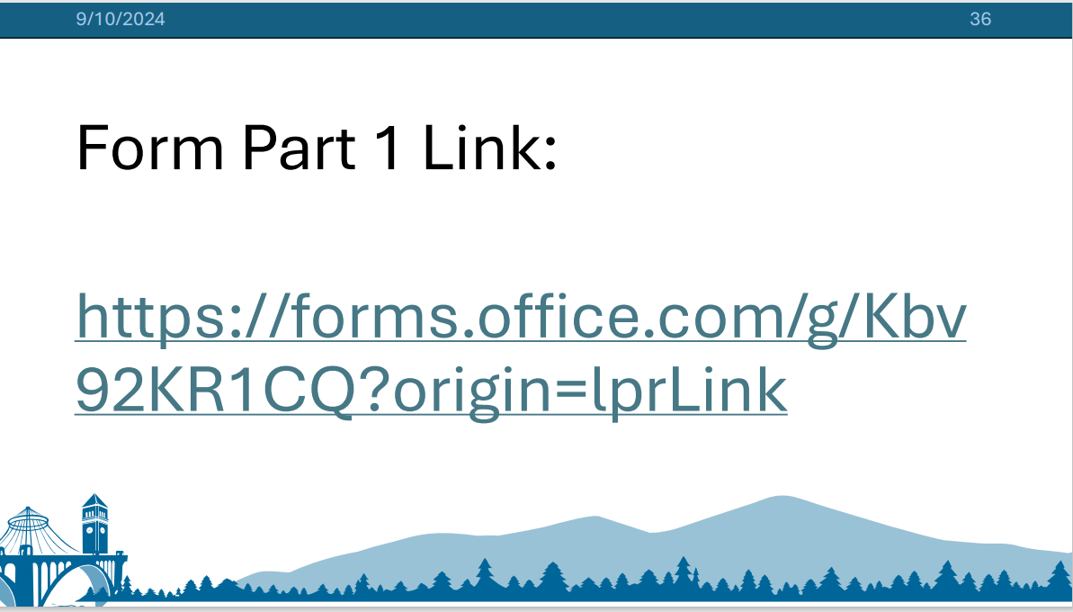

New Police Chief: Officer Kevin Hall-If new sales tax is passed they expect to have more neighborhood resources officers.
New Fire Chief: Julie O’Berg-Need sales tax to replace fire truck fleet. Trucks are 1.5 to 2million each.

Mayor Lisa brown popped in and out of the CA meeting: Started with 25million deficit in the general fund, now down to 8million. If passed the 1st year of the sales tax will not be enough to cover the deficit. She wants the funds to be transparent looking at a way to allow people to easily see how the funds are allocated. Spokane will have to get more SEP loans to pay for capital improvements. She hopes to invest in therapeutic courts (drug courts) to help deal with the Spokane County Jail issues/being full.

CHHS-Empire health continues to have engagement meetings about the scattered sites. Working with faith communities to try and get scattered sites up and running. Trying to replace 400 beds from the TRAC (Trent) homeless shelter hoping to get 8 smaller scattered sites maybe 10-20 beds per a church property. These will be rented out from the church but not operate as religious facilities. They will be low barrier (No ID required) but there will be rules, no violence allowed, no drugs. Working on good neighbor agreements. They have said this model is based on the Houston Texas model but also shared that that Texas is allowed to do/enforce things that Washington state cannot do. The scattered sites are not set in stone yet. *I asked to be placed on an email list where if a scattered site in North Indian Trail is considered that I be given a heads up so that I can share with the neighborhood council*. They are trying to set up good neighbor agreements with each scattered site that would entail things like the operatory would need a rep at every neighborhood meeting, they would need to be in charge of their trash, graffiti etc. Up for debate on what is in the good neighbor agreements is how many blocks away should they keep neighbors informed of things, what kind of security is needed. See survey link above. People can call 311 to get help with shelters.

CA decorum policy will be up for a vote at next CA meeting.
*They need somebody for the Transportation Commission , Climate Resilience Board (This person will influence Spokane Comprehensive Plan). They need somebody for the Liaison Committee, CA Budget Committee
-Saturday November 2nd there is a neighborhood summit that will have trainings, events for people interested in getting involved with the city/neighborhoods more.
- I requested a walk audit along north Indian trail from ridge crest bus stop up to meadowglen park and back down again. Samantha Henessy will look into it and walk it submit to planners, city hall reps findings. I shared that we are seeing more people walk along there and cycle with expected traffic to increase if/when the park gets built. The road is narrow with no sidewalk, trees that field of view on street corners, people speed frequently along here on their way out of the city.
-January 29th CA safety committee is going to host a town hall round table Q/A with the new police chief, judges, attorneys etc to help understand the crime/safety/legal process ask questions.

